**Kraken User Manual**

**6672 Fusion Corps**



**Overview**

Welcome to Kraken! Kraken is a data compilation app for the FRC 2023 season that was developed in R. Kraken has been in active development since the beginning of the build season, and we have finally reached a level of quality that we feel is ready to show the world!

Kraken is used in conjunction with our scouting app, Cypher, via QR code scanning. We have a specific format for all our data, so currently, Kraken pretty much only works if you scout the same data as us.

Our scouting/strategy system consists of 6 scouts using Cypher on Microsoft Surfaces we inherited from our school. There is one data entry manager who is running Kraken on another computer, and who scans in all the QR codes after each match. Our strategy team then takes the data from them and uses it to formulate match strategy. If you’ve played with us this year, you’ve probably seen us using it.

If you have any questions about Kraken, please contact our lead developer at [24brittianw@cistercian.org](mailto:24brittianw@cistercian.org).

**Gallery**

Data Entry:

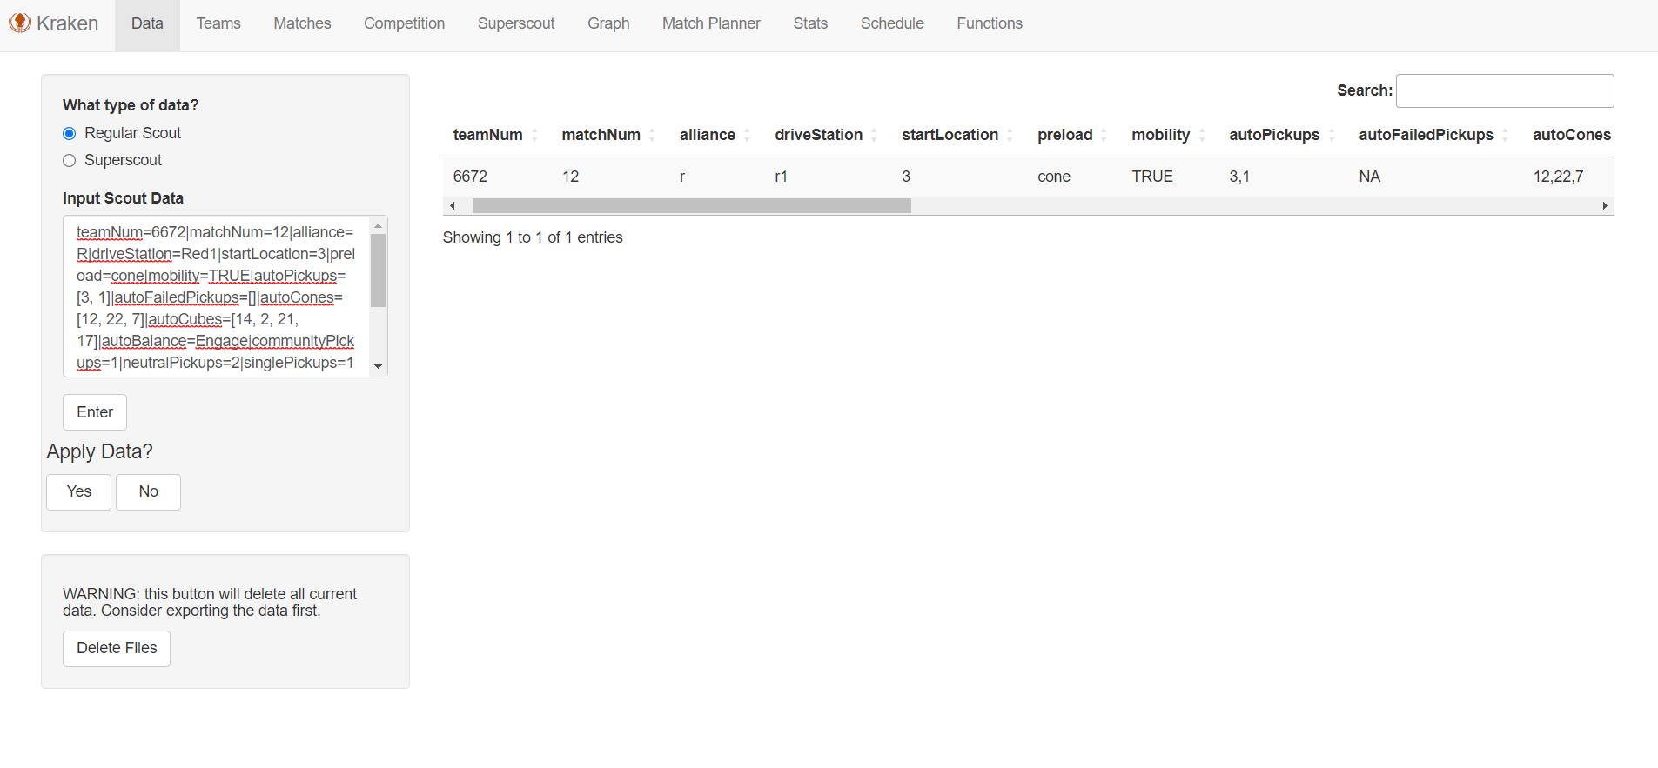

Team Search:

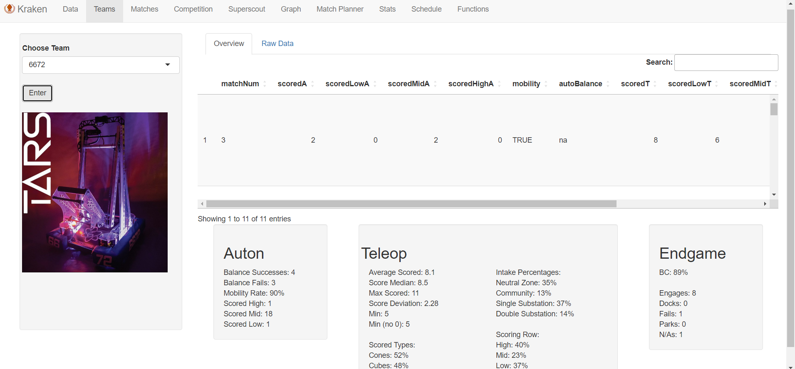

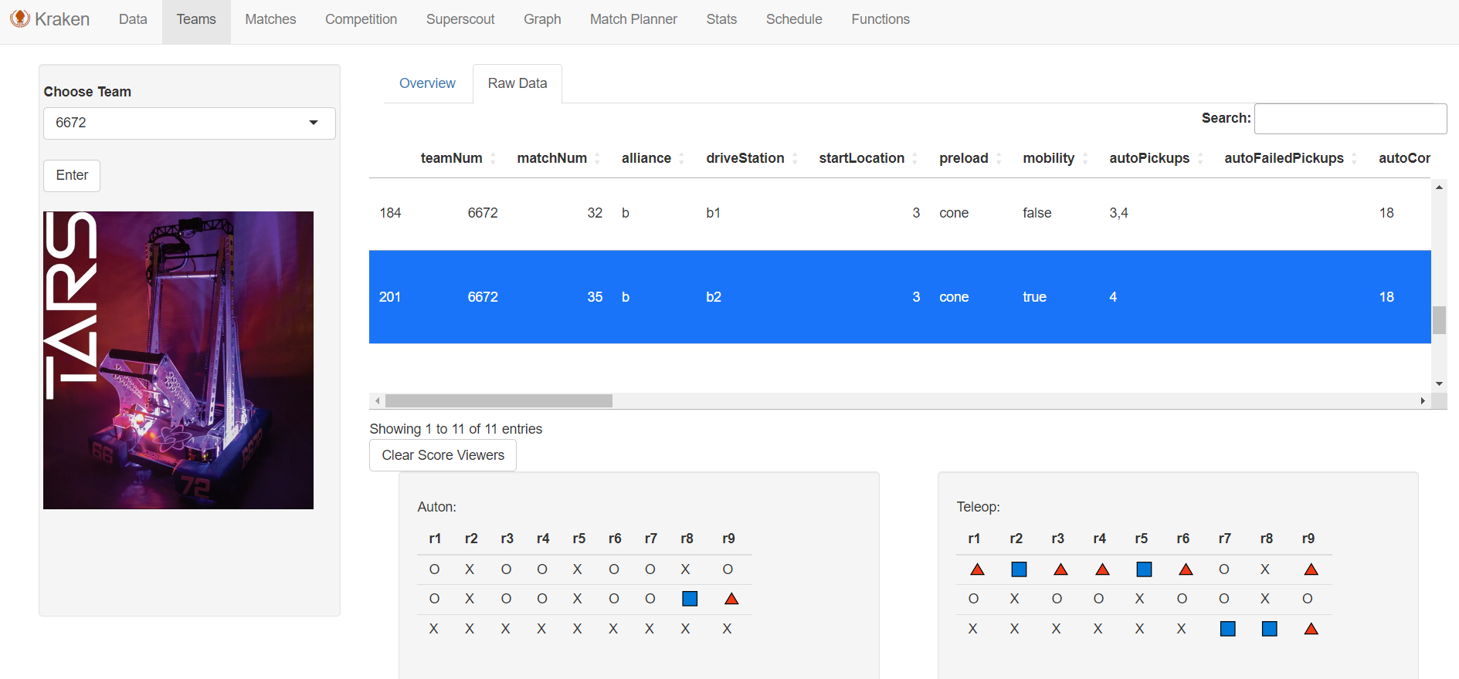

Match Search:

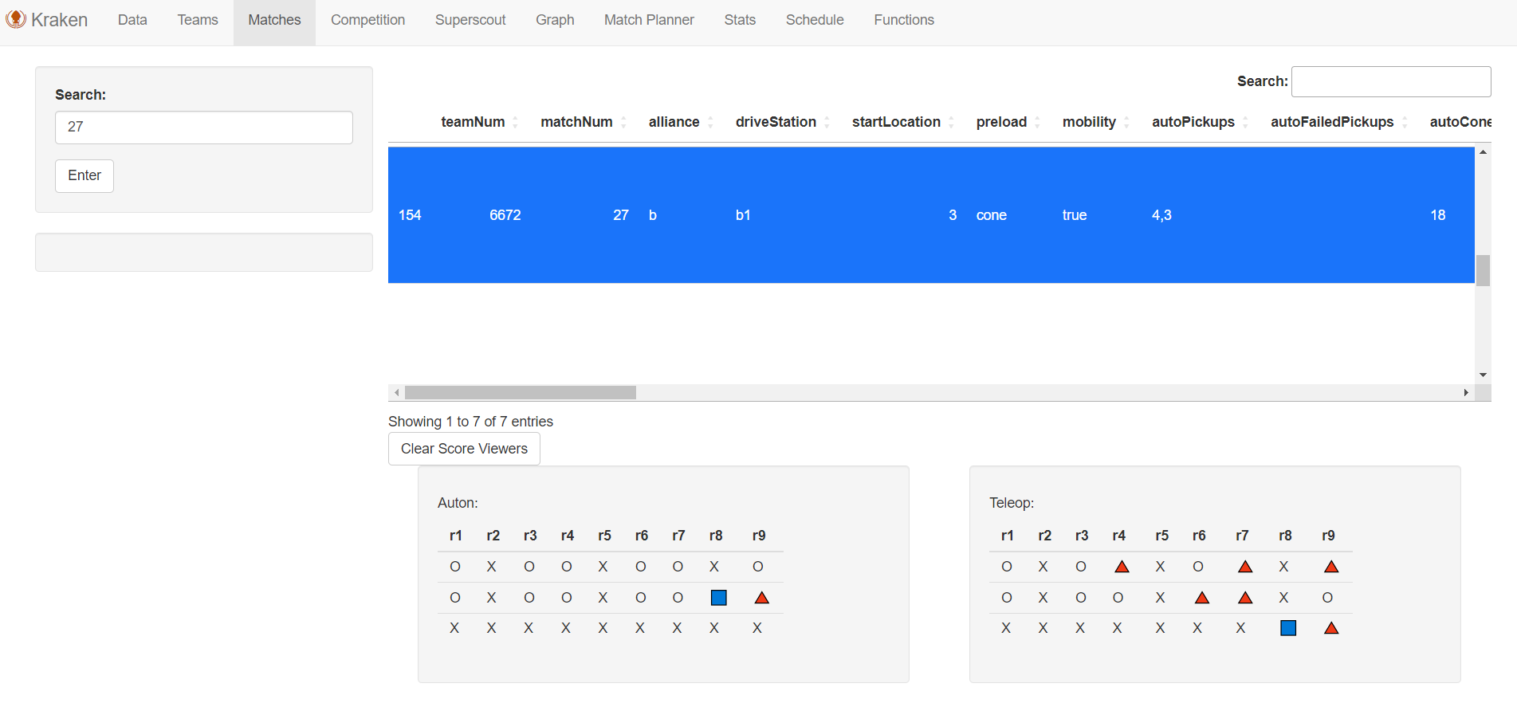

Competition:

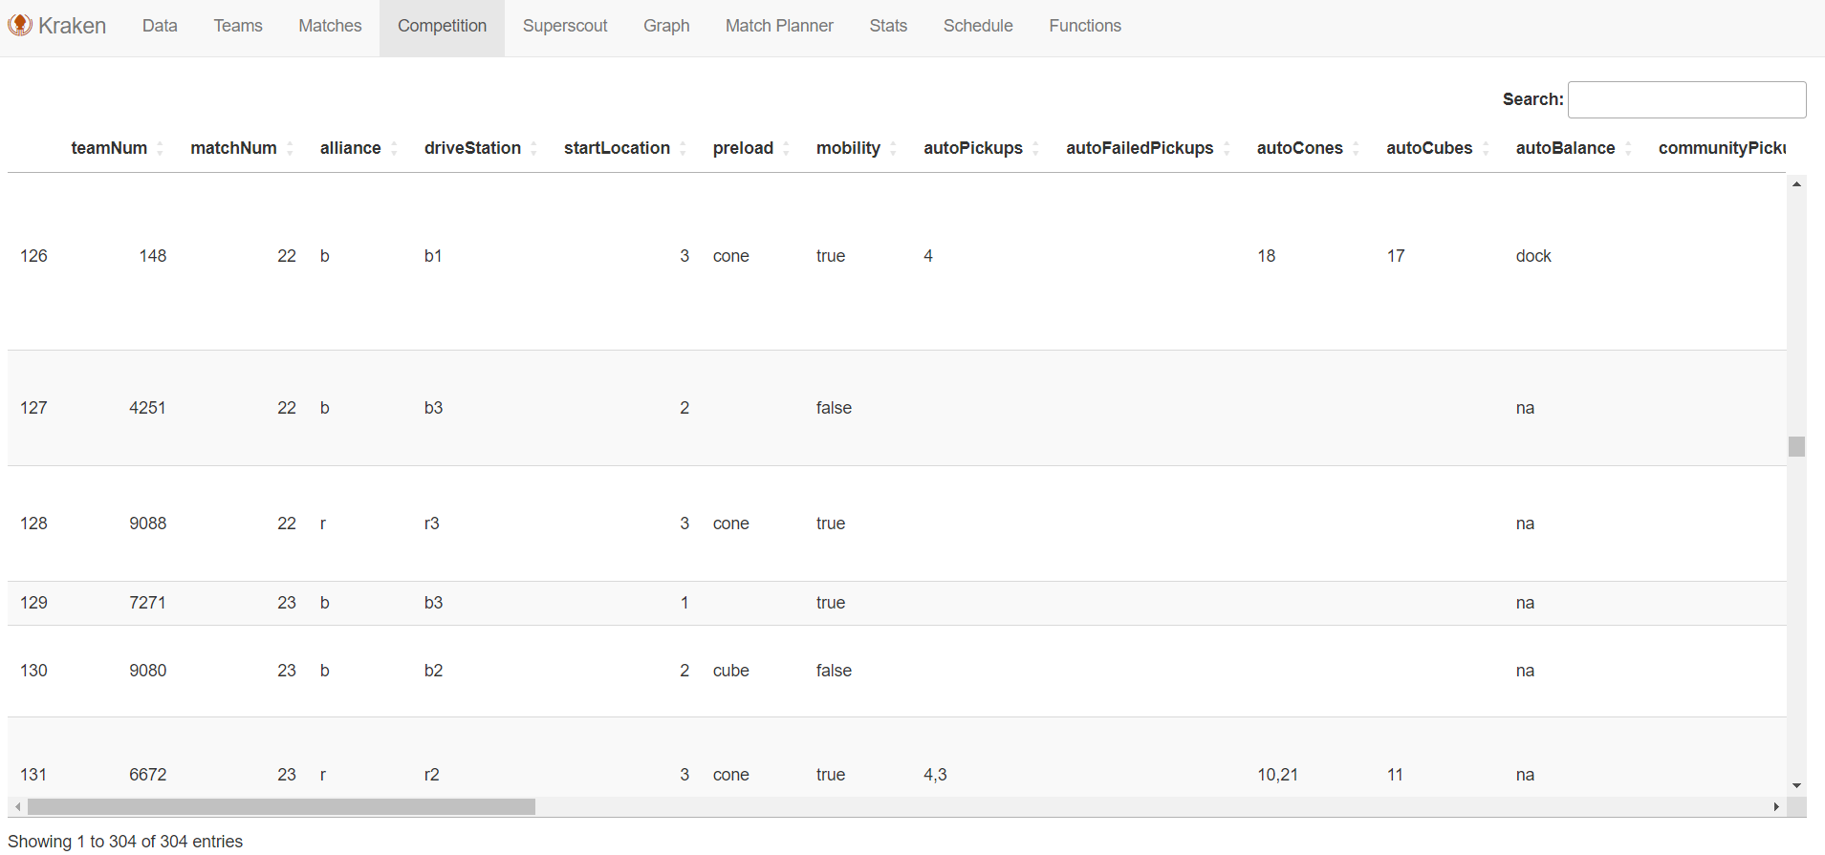

Superscout:

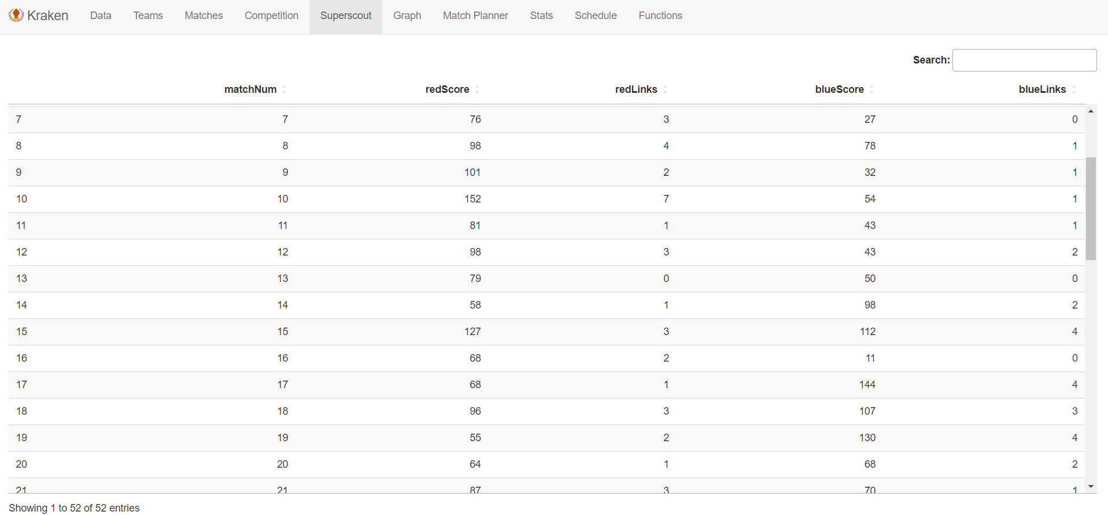

Graph:

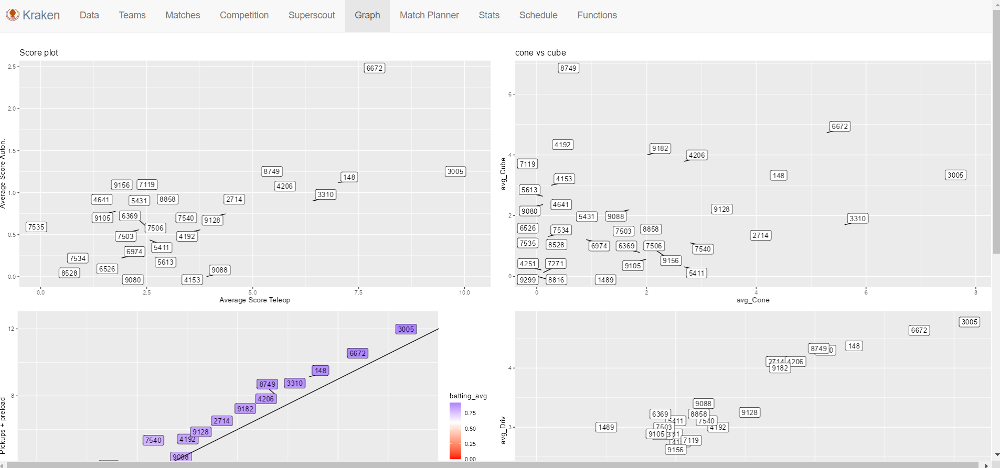

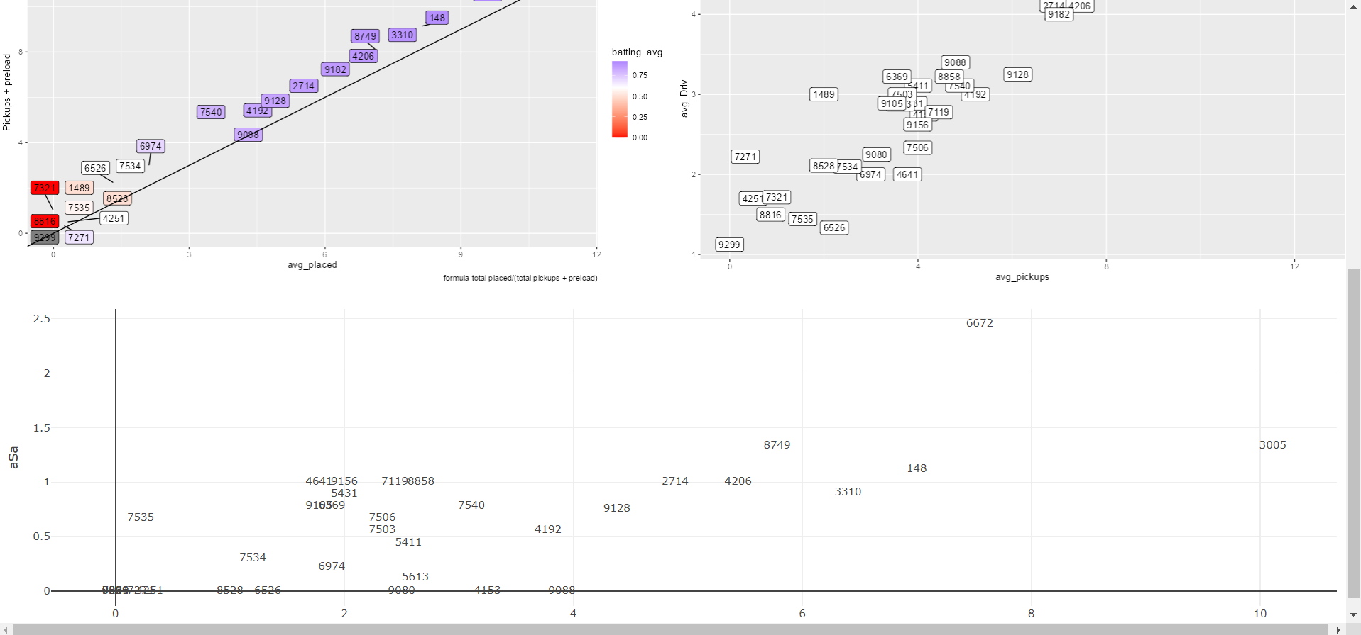

Match Planner:

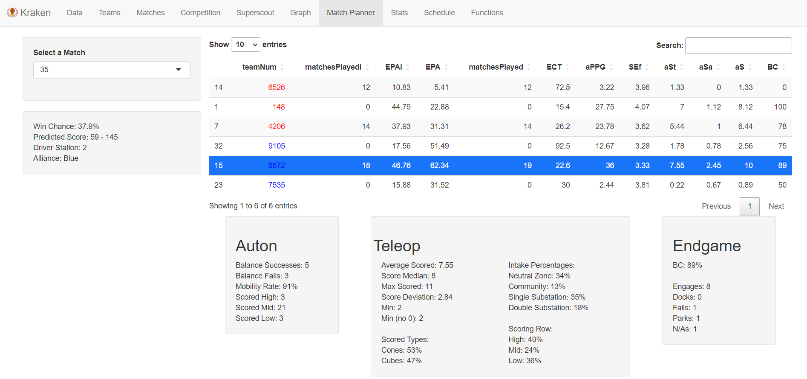

Stats:

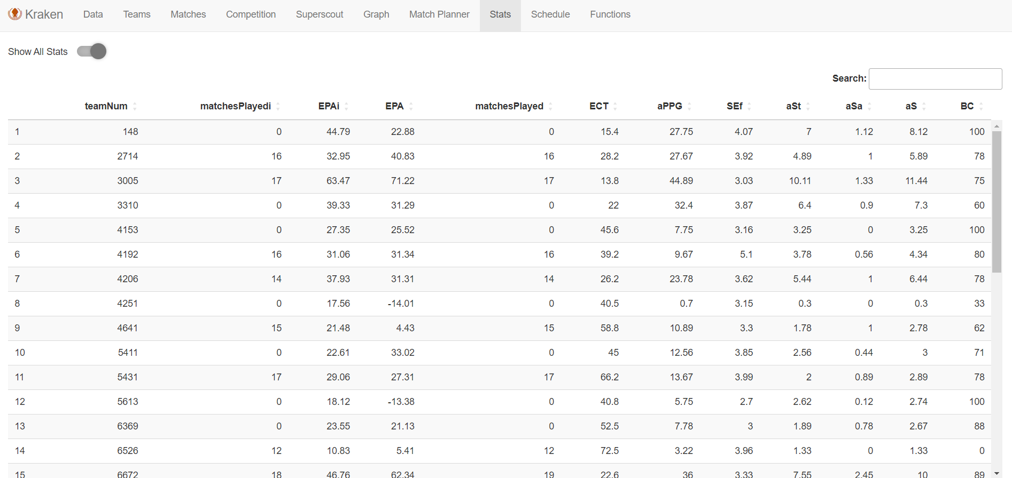

Schedule:

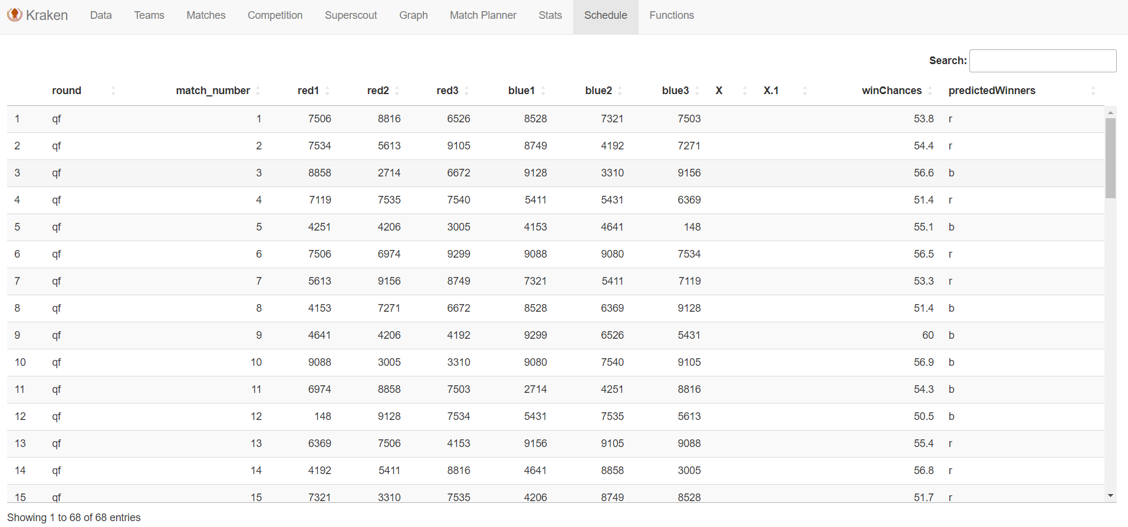

Functions:

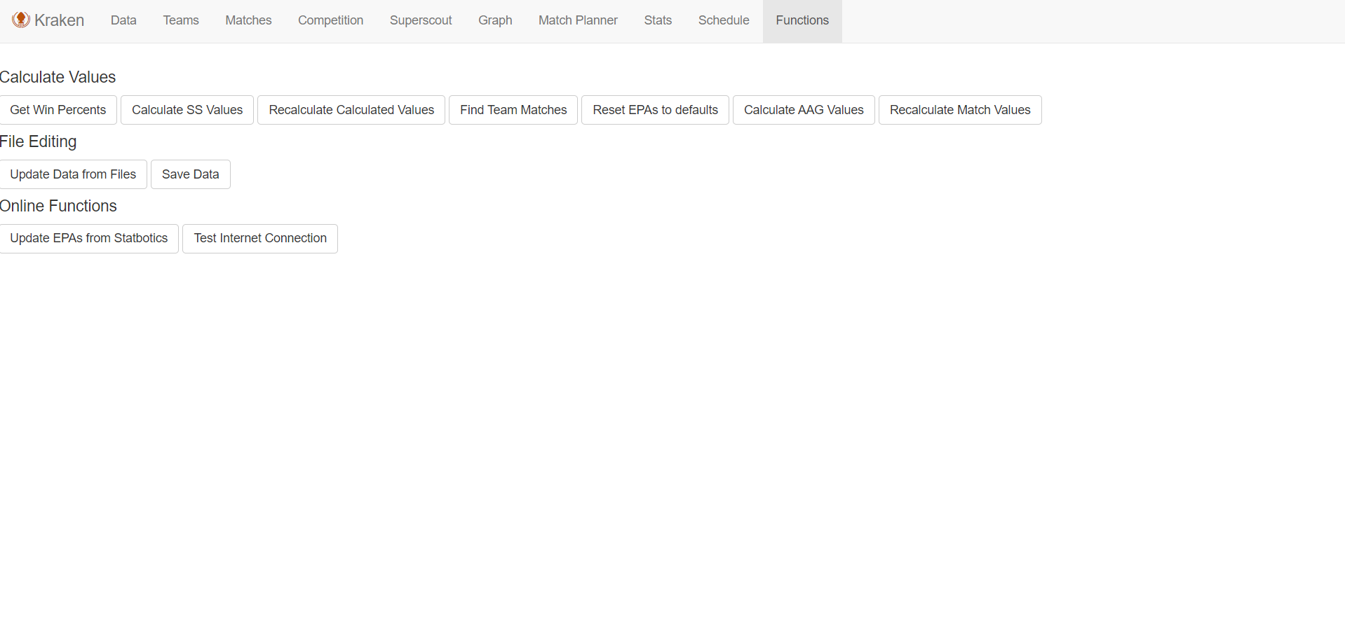

**Setup**

Kraken setup is unfortunately a bit complicated, but this guide will try to walk you through it as easily as possible.

1. **Download Kraken**

Downloading Kraken is fairly simple. Just go to [this link](https://github.com/BoRocks813/Kraken) and clone the repository on Github desktop.

1. **Download tbaR**

tbaR is another R program created by one of our mentors. It is an easy way to interface with The Blue Alliance and is quite powerful. Kraken mainly uses it to pull event schedules, but we are planning on integrating more tbaR functions into Kraken at some point. Like before, just clone [this repository](https://github.com/GKrotkov/tbaR). Make sure to note down the file path.

1. **Download R and RStudio**

R is the programming language both Kraken and tbaR are written in, while RStudio is the client with which you run them. Both can be downloaded by following the instructions [here](https://posit.co/download/rstudio-desktop/). Then, just follow the onscreen instructions.

1. **Open Kraken**

Once you’ve downloaded both R and RStudio and completed the initial setup, open Kraken in RStudio. Simply go to File -> Open File and then navigate to the Kraken repository wherever you cloned it. You want to open the “Main.R” file.

1. **Create the krakendata folder**

In an easy to access place (Documents is a good idea), create a folder called “krakendata” (the name isn’t mandatory, but just remember what you named it). This will be the folder in which Kraken saves all of your data. Make sure to note down the file path. Also, create a folder called “Pictures” within that if you want Kraken to use any pictures you take.

1. **Configure Kraken**

At the top of Main.R in Kraken, there are several variables that need to be configured. Unfortunately, some of these you may have to reupdate every time you download a new version of Kraken, and some vary by competition

* Where it says “load_all(“ and then a long file path at the top, put in the path to tbaR on your computer, following the same format as the existing path.
* tbaKey: This is the key for the specific event you are currently scouting through The Blue Alliance. The format is usually the 4-digit year, followed by the two-letter district code, followed by the 3-letter event code. For example, the 2023 First in Texas Waco event code was “2023txwac”. Sometimes this is not the easiest to guess, so you may have to do some sleuthing to find out what it is.
* path: This is the path to the krakendata (or whatever you decided to call it) folder. Enter the path, and follow the format.
* year: fairly self-explanatory
* outTeamNum: Your team number. This affects which team the match planner pulls data for (more on that later).

Ignore the ones below this, these all just affect EPA calculations.

1. **Install Required Packages**

At the very top of Main.R, you will see a list of library() calls. For each of these, make sure to install the package. You can either use the “install.packages” function in the console at the bottom, or navigate to the packages tab in the bottom left panel and click the install button there. This might take a minute to install all of these and can be a bit boring.

d

1. **Launch Kraken!I**

Now that you’ve completed all previous steps, you should be ready to launch the program. All you have to do is click the green “Run App” button in the top right of the main panel. This should open another window that the app runs in. Occasionally a glitch will happen where the window will just be blank, in which case you need to click the “Open in browser” button and run it from your browser. There are occasional other UI glitches which can be simply be solved by closing the window and restarting Kraken.

1. **Basic Troubleshooting**

If the app crashes on launch, first make sure that you’ve completed all previous steps and that there are no typos in the file path name, or other things like that. If you continue to have issues, check that you have a valid TBA event code entered. On the first startup, if there is no schedule already in the krakendata folder, the app will automatically try to pull one so there may be an issue there. If that is the issue, use a premade schedule to at least get the app launched.

**10. Buttons**

The first time you launch Kraken there are a few buttons you need to hit in the functions tab to initialize the program. You want to hit “Get Win Percents”, and “Find Team Matches,” and then it’s not a bad idea to hit “Save Data” to make a backup of your current files for later.